
WM2U Make It Happen Fund – Coldside Ward (Fairmuir, Hilltown, Law, Dudhope, The Glens and Coldside) MIHF
Information and Guidance for Applying

You can download a copy of the application form at:
https://wm2u.co.uk/coldside-make-it-happen-fund

1. Overview

The Coldside Make It Happen Fund

The Coldside Make It Happen Fund is run by local people for local people. The aim is to support and encourage local groups, by offering funding to them to support projects and initiatives that create positive change within their communities.

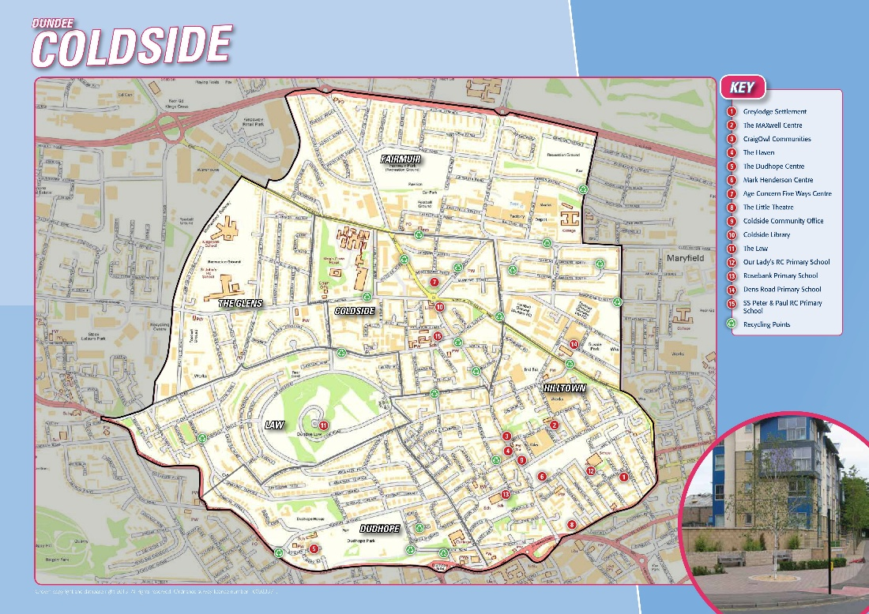

The money comes from the What Matters to You Make It Happen Fund in the Coldside ward. We have £30,000 available from this grants programme. The grants are administered by Corra, who are supporting the ‘Coldside Bright Futures’ group to run the fund.

The ‘Coldside Bright Futures’ group is made up of local people from Coldside ward who have come together to encourage community engagement to benefit the people of Coldside through:

• Bringing Families Together
• Creating a safer and better environment.
• Creating opportunities for a chance for everyone to be involved.
• Putting the feel- good factor back into communities

2. Drop-In Information Sessions in the area
You are encouraged to come for more information and help to fill out the form to a drop-in information session on:

Monday 3rd November 6.00pm- 7.00pm at Hilltown Community Centre, 15 Alexander St, Dundee DD3 7DL
Thursday 6th November 1.30pm -3.00pm at Hilltown Community Centre, 15 Alexander St, Dundee DD3 7DL

You can collect a copy of the application form at the drop-in, or download from https://wm2u.co.uk/coldside-make-it-happen-fund



3. Aims of the fund
To encourage community engagement to benefit the people of North East through:

• Bringing Families Together
• Creating a safer and better environment.
• Creating opportunities for a chance for everyone to be involved.
• Putting the feel- good factor back into communities

To further the strategic outcomes of WM2U: services will learn about what individuals and communities can do for themselves and where services might better fit in the longer term, creating a new form of public service.


4. Who can apply?

The Coldside MIHF is open to Not-for-Profit organisations based in Coldside Ward, both constituted and non-constituted, whose services are being delivered in Coldside Ward to benefit children, young people, families, and adult groups.

Organisations based in other parts of Dundee can apply where there is Children, young people & family voice from Coldside fully included in the planning and delivery of the activity.

- Applicant organisations/groups should have an annual income of less than £50,000.
- Groups must be not for profit. This means all money raised or earned is spent on the costs of providing current or future activities. The group/organisation can be formally constituted, or an informal unconstituted group. The group/organisation should have at least three people on the committee/Board of Trustees, or for unconstituted groups, at least three people involved in organising it. Community Interest Companies (CIC’s) must have three Directors where no one Director has significant control. New grassroots unconstituted groups are very welcome.
- Groups of young people that are supported by a larger organisation but have a degree of independence. For example, where the group of young people make decisions on what to do and are instrumental in the running of those activities with some support.
- Groups that are run under the LMG but have independence.
- Sports Clubs

5. What can be funded?
The fund is to benefit the people of Coldside. It can be used to fund anything that helps the group/organisation to achieve the outcomes of the fund that may include but not restricted to:

- Equipment
- Refreshment
- Rental for premises
- Trips
- One off Events
- Gala Days
- New activities
- Existing activities
- Time limited activities

7. How much can be applied for?
There is a maximum of up to £3,000 per application.

The Grant can be used for full project funding or part project funding where the balance of funds has already been secured or towards general running costs of existing activities.
The grants will be available from late January 2026 and therefore applications should not be made for activities happening before end of January 2026.



What CANNOT be funded?
- Major items such as building projects, motor vehicles and refurbishment costs.
- Activities that have already happened or things already bought.
- Activities that are for the promotion, teaching, or worship practice of any faith.
- Activities that are for the promotion of anything political.
- Mainstream activities and statutory services of public bodies such as hospitals and medical centres, schools, universities, and colleges.
- Crisis intervention funding.
- Salary costs and payments to CIC Directors to do work
- Application on behalf of another group/organisation.
- Volunteer expenses.
- Food parcels to be given out/Cash or vouchers for food to be given out for those in poverty
- Overseas trips
For example, a local authority nursery cannot apply. A group of parents from the nursery who wish to run an activity themselves, can apply. Similarly, Parent Councils of schools can apply to run activities themselves.

A Community Interest Company (CIC) cannot apply to pay its directors to run an activity. If another organisation (which meets the criteria), wishes to engage the CIC to provide an activity for their organisation, then that organisation can apply for the costs of engaging the CIC.

8. Writing your application
Thinking about your project:
- What will change because of the project and who will benefit?
- How does the project benefit the people of North East through:

  - Bringing Families Together
  - Creating a safer and better environment.
  - Creating opportunities for a chance for everyone to be involved.
  - Putting the feel- good factor back into communities

- How many people will take part?
- What do you need to run your project and what does this cost?



9. Where and when to send your application

Send your application by 5pm on Friday 5th December by email to Kirsten Brownlie kirsten.brownlie@dundeecity.gov.uk or hand in to one of the following Community Centres in a sealed envelope for attention of Kirsten Brownlie

- Hilltown Community Centre, 15 Alexander St, Dundee DD3 7DL

10. How will decisions be made?
The Coldside Bright Futures group will
- consider which applications fit the guidelines.
- invite those that best fit to an event in the community on a date to be confirmed (this event must be attended).
- Invite each group under consideration for funding to share their project idea with the Coldside Bright Futures group and other applicants in person.
- Give feedback to those that don’t fit.



11. Award Conditions

- Allocated funds must be spent within one year of receipt. Funds cannot be spent before a grant is allocated and can only be spent as outlined in the grant application.
- Groups may be asked to undertake free safeguarding training where appropriate.
- Instructions/conditions for claiming awarded grants will be sent with award letters along with any other conditions.
- An organisation may submit one funding applications per year.
- Groups running for longer than 5 years can only apply for new projects. Existing projects running for longer than 5 years will not be funded.
- If invited to the event on a date to be confirmed a representative must attend, to qualify for a grant

12. How will the money be paid?
- Corra Foundation are handling the administration and payment of the grant.
- The grant will be paid in one instalment into the bank or credit union account of the group.
- If the group does not have a bank account, we can pay the grant into the account of another group (Buddy Group) which agrees to hold the money for you.

13. What happens after?
We want to hear how you’re getting on with your project.

- We plan to visit projects to find out how things are going
- We ask that you collect photos, video, art and stories from the community participants and your own learning, to show the activity and the difference it made to people.

You can collect a copy of the application form at the drop-in, or download from https://wm2u.co.uk/Coldside-make-it-happen-fund

What Matters to You is supported through a partnership between The Hunter Foundation and BBC Children In Need. The Make It Happen Fund is part of the What Matters to You approach with funding from BBC Children in Need, The Hunter Foundation, Northwood Charitable Trust, The Robertson Trust and William Grant Foundation
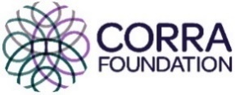
The Corra Foundation is a charity registered in Scotland (No SC009481) and is also a company limited by guarantee (No SC096068).


“Coldside Bright Futures” is a group of parents recruited from Coldside ward who have designed, developed and are the community voices that make decisions on the funding distributed by What Matters to You via The Corra Foundation.

