
WM2U Make It Happen Fund – Coldside Ward (Fairmuir, Hilltown, Law, Dudhope, The Glens and Coldside) MIHF 2026
Information and Guidance for Applying

You can download a copy of the application form at:
https://wm2u.co.uk/coldside-make-it-happen-fund

1. Overview

The Coldside Make It Happen Fund

The Coldside Make It Happen Fund is run by local people for local people. The aim is to support and encourage local groups, by offering funding to them to support projects and initiatives that create positive change within their communities.

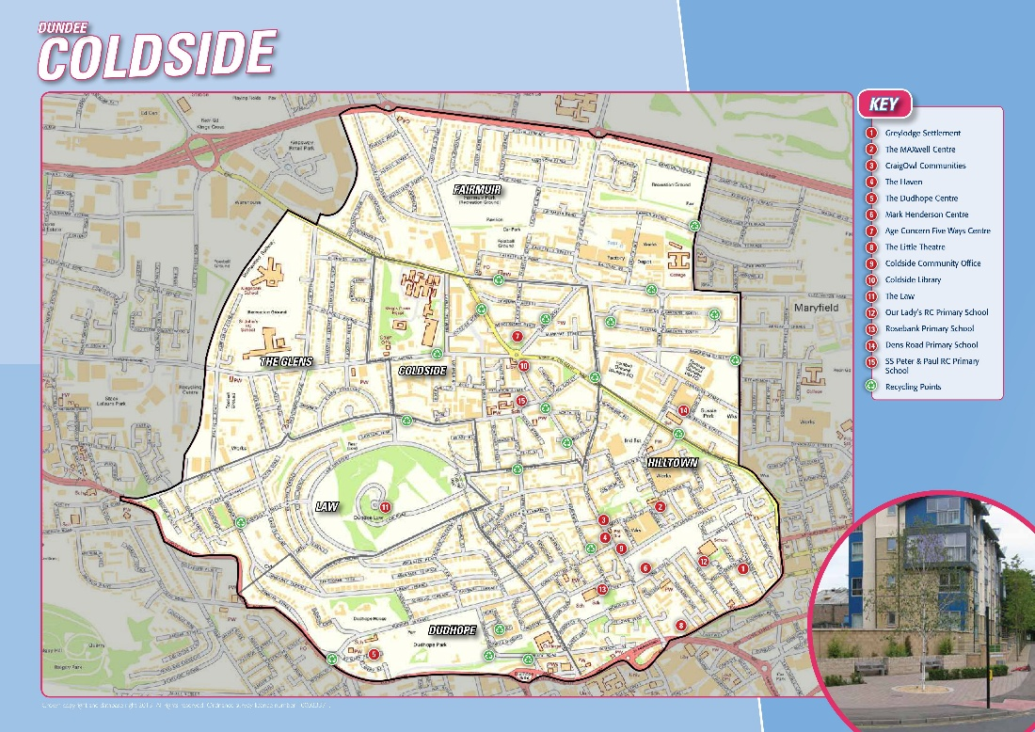

We have £30,000 available from this grants programme. The grants are administered by Corra, who are supporting the ‘Coldside Bright Futures’ group to run the fund.

The ‘Coldside Bright Futures’ group is made up of local people from Coldside ward who have come together to encourage community engagement to benefit the people of Coldside.

2. Drop-In Information Sessions in the area
You are encouraged to come for more information and help to fill out the form to a drop-in information session on:

Tuesday 22nd September 5.00pm- 7.00pm at Hilltown Community Centre, 15 Alexander St, Dundee DD3 7DL
Wednesday 30th September 1.00pm -3.00pm at Hilltown Community Centre, 15 Alexander St, Dundee DD3 7DL

You can collect a copy of the application form at the drop-in, or download from https://wm2u.co.uk/coldside-make-it-happen-fund



3. Aims of the fund
To encourage community engagement to benefit the people of Coldside through:

- Bringing families Together
- Improving physical or mental health
- Creating a safer and better environment
- Creating opportunities for everyone to be involved
- Restoring community pride

To further the strategic outcomes of WM2U: services will learn about what individuals and communities can do for themselves and where services might better fit in the longer term, creating a new form of public service.


4. Who can apply?

The Coldside MIHF is open to Not-for-Profit organisations or groups based in Coldside Ward, both constituted and unconstituted, whose activities are being delivered in Coldside Ward to benefit people in the community including children, young people, families, and adults. New unconstituted groups are very welcome to apply.

Organisations based in other parts of Dundee can apply where there is community voice from Coldside fully included in the planning and delivery of the activity, the activity happens in Coldside, and the activity is to benefit people mainly from the Coldside area.

- Applicant organisations/groups should have an annual income of less than £50,000.
- Groups must be not for profit. This means all money raised or earned is spent on the costs of providing current or future activities. The group/organisation can be:
  - formally constituted
  - informal or unconstituted
  - The group/organisation should have at least three people on the committee/Board of Trustees, or for unconstituted groups, at least three people involved in organising it.
  - Community Interest Companies (CIC’s) must have three Directors where no one Director has significant control.

- Groups of young people that are supported by a larger organisation but have a degree of independence. For example, where the group of young people make decisions on what to do and are instrumental in the running of those activities with some support. The application must be signed by someone over the age of 18yrs, this may be a support worker.

- Groups that are run under a community umbrella body but have independence – see below.

In recognition that many small unconstituted groups may be hosted or nested in organisations that may or may not have income over £50,000, these small groups can apply where:

- The hosting or umbrella organisation is based in Dundee.

- The group has independence regarding its activities and finances i.e it makes its own decisions on what activities to run and how these are paid for.

- Applications must have the voice of the group who are applying and be written by the group and not a worker of the hosting organisation. A worker can support the group to write the application.

- The contact person is someone from the group and not a worker of the hosting organisation.

The key is that it is not the host organisation that is applying it is the group.

In addition to the provision for independent groups hosted by a community umbrella body:

A community umbrella body which has income under £50,000, and which runs its own initiatives may make up to three applications, up to a total of £3000, for its own initiatives.

5. Who can’t apply?

Businesses
Public Bodies
Projects of organisations where the organisation has an income larger than £50000
Organisations applying on behalf of another organisation

6. What can be funded?
The fund is to benefit the people of Coldside. It can be used to fund anything that helps the group/organisation to achieve the outcomes of the fund that may include but not restricted to:

- Equipment
- Refreshment
- Venue hire
- Trips
- One off Events
- Gala Days
- New activities
- Existing activities
- Time limited activities
- External tutors

7. How much can be applied for?
All applicants can apply for up to £3000. Please only apply for what you reasonably need to run your activity or project. The panel may award the full grant or part of the costs. Please try to be accurate in your costs.

The Grant can be used for full project funding, or part funding of a bigger project where the balance of funds has already been secured.
The grants will be available from mid December 2026 and therefore applications should not be made for activities happening before end of December 2026.



8. What CANNOT be funded?
- Major items such as building projects, motor vehicles and refurbishment costs.
- Activities that have already happened or things already bought.
- Activities that are for the promotion, teaching, or worship practice of any faith.
- Activities that are for the promotion of anything political.
- Crisis intervention funding
- Salary costs of staff
- Payments to CIC Directors to do work
- Activities that are not run by the applicant
- Equipment that is to be passed onto another organisation
- Payments to volunteers except for essential expenses incurred.
- Food parcels to be given out/Cash or vouchers for food to be given out for those in poverty
- Overseas trips

Some examples of who can and can’t apply

A local authority nursery cannot apply. A group of parents from the nursery who wish to run an activity themselves, can apply as an unconstituted group. Similarly, Parent Councils of schools can apply to run activities themselves, but not to purchase equipment for the school, or pay for school run activities.

A Community Interest Company (CIC) cannot apply to pay its directors to run an activity. If another organisation (which meets the criteria), wishes to engage the CIC to provide an activity for their organisation, then that organisation can apply for the costs of engaging the CIC.

A group is constituted and runs in the local community centre. Under the constitution it keeps accounts and the annual accounts are shared at an AGM. It can apply for up to £3,000.

A community centre hosts a weekly craft group. The group is not constituted but organises itself, decides what to do and raises its own money for materials. Its finances are included under the accounts of the community centre but shown separately. The group can apply for up to £3000.

The management committee of a community centre, which has income of under £50,000, organises several of its own initiatives. This includes a group it started but has not yet reached the stage of running itself. The management committee also runs events such as a Christmas lunch. The management committee can make up to three applications for separate initiatives, up to a total of £3000.

9. Writing your application


Thinking about your activities or project:
- What will change because of the activities and who will benefit?
- How does it benefit the people of Coldside through:

- Bringing families Together
- Improving physical and mental health
- Creating a safer and better environment
- Creating opportunities for everyone to be involved
- Restoring community pride

- How many people will take part?
- What do you need to run your activities and what does this cost?

10. Where and when to send your application

Send your application by 5pm on Monday 12th October by email to Kirsten Brownlie kirsten.brownlie@dundeecity.gov.uk or hand in to one of the following Community Centres in a sealed envelope for attention of Kirsten Brownlie

- Hilltown Community Centre, 11 Alexander St, Dundee DD3 7DR

11. How will decisions be made?

The Coldside Bright Futures group will
- consider which applications fit the guidelines.
- invite those that best fit to an event in the community on 20th November (this event must be attended).
- Invite each group under consideration for funding to share their project idea with the Coldside Bright Futures group and other applicants in person.
- Give feedback to those that don’t fit.

In the event of the fund being oversubscribed, priority will be given to new groups and new initiatives.

12. Award Conditions

- Allocated funds must be spent within one year of receipt. Funds cannot be spent before a grant is allocated and can only be spent as outlined in the grant application.
- Groups may be asked to undertake free safeguarding training where appropriate.
- Instructions/conditions for claiming awarded grants will be sent with award letters along with any other conditions.
- An organisation (other than a community umbrella organisation or LMG) may submit one funding applications for this round.
- If invited to the event on a date to be confirmed a representative must attend, to qualify for a grant

13. How will the money be paid?
- Corra Foundation are handling the administration and payment of the grant.
- The grant will be paid in one instalment into the bank or credit union account of the group.
- If the group does not have a bank account, we can pay the grant into the account of another group (Buddy Group) which agrees to hold the money for you.

14. What happens after?
We want to hear how you’re getting on with your project.

- We plan to visit projects to find out how things are going
- We ask that you collect photos, video, art and stories from the community participants and your own learning, to show the activity and the difference it made to people.

You can collect a copy of the application form at the drop-in, or download from https://wm2u.co.uk/Coldside-make-it-happen-fund

What Matters to You is supported through a partnership between The Hunter Foundation and BBC Children In Need. The Make It Happen Fund is part of the What Matters to You approach with funding from BBC Children in Need, The Hunter Foundation, Northwood Charitable Trust, The Robertson Trust and William Grant Foundation

The Corra Foundation is a charity registered in Scotland (No SC009481) and is also a company limited by guarantee (No SC096068).


“Coldside Bright Futures” is a group of parents recruited from Coldside ward who have designed, developed and are the community voices that make decisions on the funding distributed by What Matters to You via The Corra Foundation.

